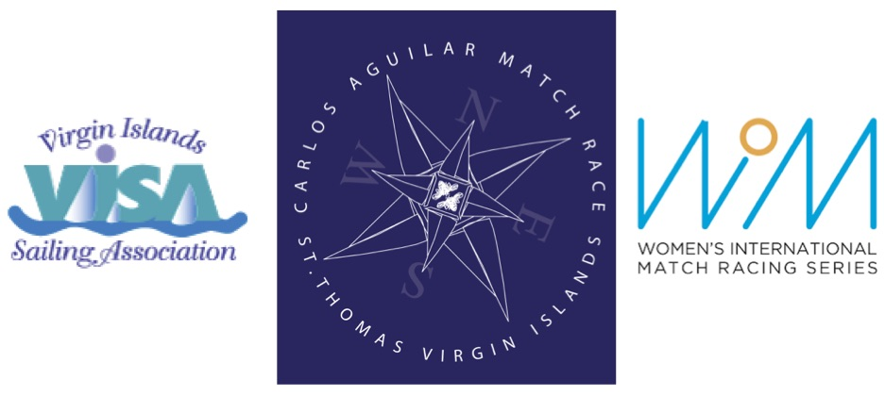

2017 CARLOS AGUILAR MATCH RACE
Virgin Islands Sailing Association
Women’s Match Race
Racing Days: 30 November - 03 December 2017
Registration and Practice Sailing: 28 – 29 November 2017

REQUEST FOR INVITATION
(Please submit by 15 September 2017)

I would like an invitation to the 2017 Carlos Aguilar Match Race:

Name:

Address:

City, State, Postcode:

Country:

Home Phone:

Work/Cell Phone:

E-mail:

World Sailing Sailor ID:

To submit request, please complete this form and e-mail to Verian Tuttle verianaguilar1@gmail.com and cc Liz Baylis liz@wimseries.com

